Programming Test :Learning Activation in Neural Network

Name – wajoud H Noorani
email – Wajoudnoorani59@gmail.com

This Technical Report is based on three data sets which are classified and analyzed with different activation functions: datasets ( iris, mnist , bank notes)

My Dataset :
iris - https://archive.ics.uci.edu/ml/machine-learning-databases/iris/iris.data
mnist – fom keras data set (from keras.datasets import mnist)
bank-note- https://raw.githubusercontent.com/jbrownlee/Datasets/master/banknote_authentication.csv

Common Setup for the Datasets :
Since Few steps are common for the initial stage of this algorithm ill explain the common step below

1 – To upload any dataset we can use Pandas library :
Eg – dataset = pd.read_csv( url , or direct data set name )

2 – To select the paramentrs for k0 , k1 by dividing the data set with respect to its contains
in my code i have paramentrs k0 ,k1 as x , y

3 – Since we have words or string in our data set we need to convert them into arrays or number to classify it
i have used Labled encoder function to transform the parametres

4 – To classify any model we need to splite the data set into tranning , testing .
In my code i have used from sklearn , train test-split model with test size as 20 % on any ramdom simple

Iris Dataset
About the dataset, the iris dataset consists of 3 different types of iris plants including the parameters of the plants. We consider 1 parameter which includes all the different parameters of the plans and 2 parameters the names of the plant. To classify the data set I used Rectified Linear unit(Relu ) in the input activation function and softmax as the output layer activation function. The Below plot represents the Relu function.
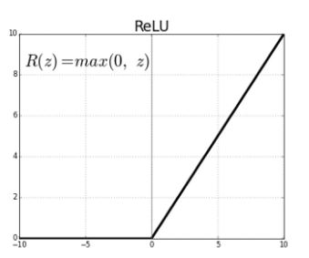

Samplinf of parametes :
#Paramentre k0,k1
X= dataset.iloc[:,0:4].values
Y = dataset.iloc[:,4].values

F1 score -confussion matrix
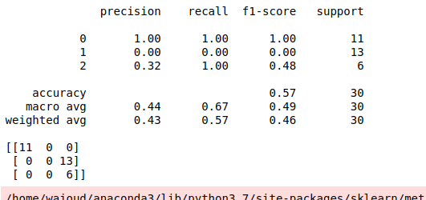
Model Accuracy

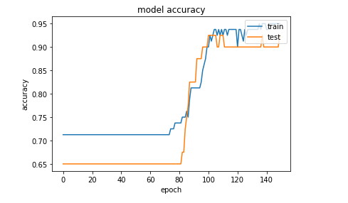
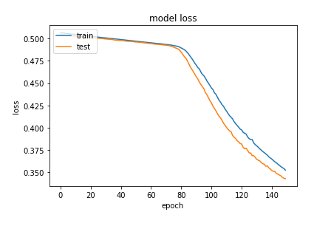
Model loss
Bank Note Data set

Sampling parametrs
X = df.values[:, :-1]
y = df.values[:, -1]

Learning curve

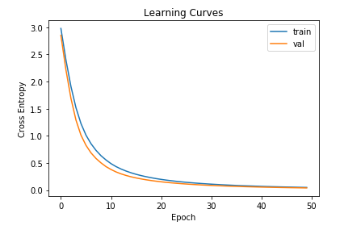
Model accuracy

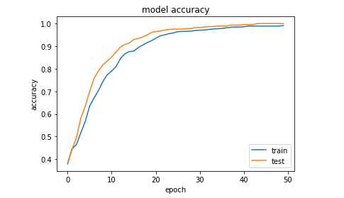

Mnist Dataset

This data set consists of an image of a different handwritten number. Which we classified. To classify this dataset I used the sigmoid activation function for input hidden layer and softmax for output activation function with input size (28,28)

F1 Accuracy :
precision recall f1-score support

0 0.87 0.93 0.90 980
1 0.92 0.91 0.92 1135
2 0.80 0.81 0.80 1032
3 0.67 0.83 0.74 1010
4 0.46 0.83 0.59 982
5 0.71 0.61 0.66 892
6 0.72 0.95 0.82 958
7 0.86 0.88 0.87 1028
8 0.80 0.54 0.64 974
9 0.50 0.00 0.01 1009

accuracy 0.73 10000
macro avg 0.73 0.73 0.69 10000
weighted avg 0.73 0.73 0.70 10000

Model accuracy
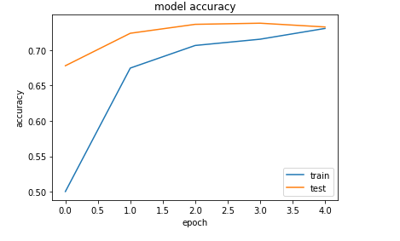

Model lose :

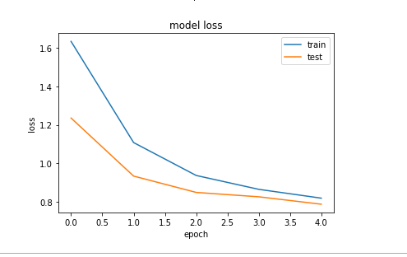

All the 3 Code are uploaded in github
GitHub Link : https://github.com/wajoud/Monk-AI-Programming-Test-

